Problem set 1

1) 26,001 occurrences were emitted from the MacroStrat database.

nrow(DataPBDB)

[1] 35419

> nrow(MacroPBDB)

[1] 9418

35419-9418

[1] 26001

2) The data were not included here because not every continent is North America, and North America is not the only continent. Not all of North America is even on North America\*, so the MacroStrat database is limited to the present-day political boundaries that define “North America” and the fossils found therein.

Problem Set 2

1. sort(specnumber(OrderMatrix))

length(sort(specnumber(OrderMatrix)))

Lagers<-c(sort(specnumber(OrderMatrix)))

Lagers[149:158]

Parker Slate Snowy Range Fm Weymouth Fm Langston Fm Forteau Fm

16 16 16 17 17

Wheeler Shale Marjum Limestone Kinzers Fm Stephen Fm

Chancellor

18 22 24 24 27

CandidateUnits<-c("Parker Slate","Snowy Range Fm","Weymouth Fm","Langston Fm","Forteau Fm","Wheeler Shale","Marjum Lm","Kinzers Fm","Stephen Fm","Chancellor")

CandidateUnits

[1] "Parker Slate" "Snowy Range Fm" "Weymouth Fm" "Langston Fm" "Forteau Fm"

[6] "Wheeler Shale" "Marjum Lm" "Kinzers Fm" "Stephen Fm" "Chancellor"

2)

apply(GenusMatrix,2,sum)

sort(apply(GenusMatrix,2,sum))

GenusFrequencies<-sort(apply(GenusMatrix,2,sum))

3) barplot(table(GenusFrequencies))

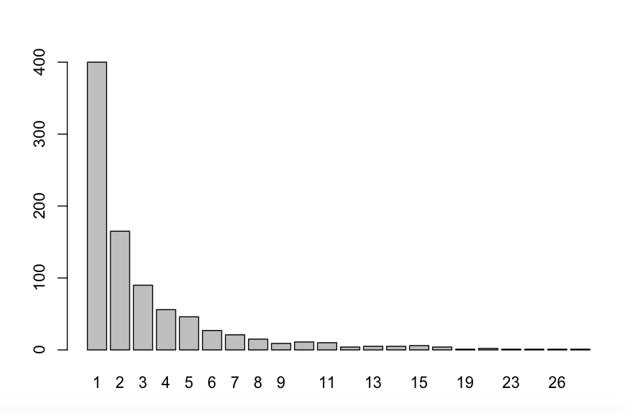

4) This type of curve is called a hollow curve.

5) Rare<-c(which((GenusFrequencies)==2))

> Genera<-c(which((GenusFrequencies)<2))

> RareGenera<-c(Rare,Genera)

> length(RareGenera)

[1] 565

>

Problem Set 3

1) GenusMatrix[CandidateUnits,]

2) The four most likely Lagerstatten candidates are the four that have the highest amount of rare genera AND the highest richness of orders:

sort(PercentShared)

Langston Fm Snowy Range Fm Wheeler Shale Kinzers Fm Parker Slate

0.1632653 0.1951220 0.2307692 0.2586207 0.2812500

Stephen Fm Marjum Limestone Forteau Fm Chancellor Weymouth Fm

0.3055556 0.3559322 0.5652174 0.5714286 0.6764706

These top four are the Weymouth, Chancellor Group, Forteau Fm, and Marjum lm.

3) The Chancellor Group includes the Burgess Shale, which is the type locality for the Cambrian Explosion and the locality where it was first described. The elaborate soft-body configurations, many not analogous to modern organisms, made paleontologists rethink the paradigm that complexity had evolved slowly over time.